REQUEST FOR PROPOSAL

CEA / MRE System



Table of Contents

Introduction 2

Brief about the required proposal 2

Confidentiality 2

Instructions and special provisions 2

Instructions for bidding 2

Statement of work 2

Cost and pricing 3

Payments and acceptance 3

Change to the contract 3

Invoices 3

Bid acceptance 3

Proposal submittals 3

Return of Documents/Tenderer’s Expense 3

Terms and conditions 4

Pricing 4

Vendor Contact 4

Scoring and Evaluation Matrix 4

Contract 4

Vendor Terms and Conditions 4

Proposal Format 4

Financial Proposal 4

Technical Proposal 5

Introduction 5

Deliverables 5

Functional Requirements 5

Budget Management 5

Creation of Projects 5

Closure of Projects 6

Expenditure Request Management 6

Creating an Expenditure Request 6

Integration of Purchase Requisition 9

Tracking of Expenditure Request 9

Maintenance of Completed CEA 9

Validations 9

Non-functional 9

System Administration 9

Approval Group Management 9

Approver Substitute Setup 11

Item Category Approver Setup 11

Role Security Setup 11

# Introduction

This document constitutes a formal Request for Proposal (RFP) to solicit proposals from qualified vendors for a capital expenditure software solution that would replace the current CEA/MRE System used in GARMCO. This RFP provides all bidders with ample information to enable the preparation of a valid and acceptable response to the requirements and specification guidelines defined herein.

## Brief about the required proposal

GARMCO will be selecting a vendor who can provide an IT software solution (as a web platform), which will replace the current outdated system used in the company.

## Confidentiality

All information contained in this RFP and any additional information received during the RFP process is confidential and proprietary to GARMCO, and reproduction, disclosure or use of any information contained in this RFP by any means, in whole or in part, for any reason other than for the purpose of responding to the RFP, is strictly prohibited. GARMCO is neither required nor obliged to discuss or explain the reasons for the acceptance or rejection of any product or service included in the response to this RFP.

# Instructions and special provisions

The bidder who wishes to respond to this tender or subcontract companies should have sufficient competencies in installing, maintaining, and providing customer support for the software solution within the Kingdom of Bahrain. For bidders to be considered and qualified as viable candidates for this project, suppliers might be requested to provide proof of authorization and any other supporting documents/materials requested for the proposal submission detailed hereafter.

GARMCO is requesting complete and comprehensive sealed proposals for the capital expenditure management system as per the functional requirements and system specifications detailed in this document.

Any further clarifications required by the bidding Vendors are to be communicated and addressed to the following recipients:

Khalid Jalal - [khalid.jalal@garmco.com](mailto:khalid.jalal@garmco.com)

Hussain Alsabah - [hussain.alsabah@garmco.com](mailto:hussain.alsabah@garmco.com)

Nagendra Seetharam – [nagendra.seetharam@garmco.com](mailto:nagendra.seetharam@garmco.com)

All bidding Vendors will be copied on any responses to clarifications.

## Instructions for bidding

Proposals must be in the format furnished by GARMCO and must be uploaded on the etendering website and endorsed, “CEA/MRE SYSTEM".

Requirements for this proposal could include:

1. Approach and Project Schedule
2. Methodology
3. Deliverables (Security Assessment Report/ VAPT report etc.)

Vendors must respond to RFP request declaring intent to bid within **3 days** of receiving the RFP.

## Statement of work

GARMCO is requesting proposals from the bidding Vendors to include the following:

1. Cost of the software solution including the implementation, maintenance and licenses.
2. GARMCO Requested Services.
3. Value Offered Services.

Each of the above-mentioned points will be discussed in more detail in Proposal Format.

## Cost and pricing

The financials submitted by the tenderer shall be the full and total cost of the IT software solution as identified in the RFP. All applicable costs, charges or fees shall be included as part of the price of the implementation and testing. GARMCO will not be responsible for or pay for any costs, charges or fees not included or identified in the offer.

## Payments and acceptance

GARMCO standard payment policy shall apply and begin upon successful implementation, testing, receipt of reports with recommendations and acceptance by GARMCO ICT Department. Unless otherwise specified herein, final acceptance will be with the specified GARMCO ICT representative.

## Change to the contract

GARMCO reserves the right to amend the contract after award as new services are identified and required. New services shall be negotiated as an addition to the contract and added by Contract Change Order. *All additions to the contract or changes in service in the contract will be made by written Change Order*.

## Invoices

Original invoices shall be sent to GARMCO Accounts Payable department at the end of the successful implementation and acceptance.

## Bid acceptance

Bidders should specify in the Financial Proposal that their offer is valid for a period of **30 days** from the submission date instructed by GARMCO.

GARMCO does not bind itself to accept the lowest offer or provide a reason or reasons for the acceptance or rejection of any offer. GARMCO reserves the right to select or rule out any bidder based upon its sole discretion and without providing any justification or clarification to invited bidders.

## Proposal submittals

Vendors must submit the proposal no later than **30th September 2022** to:

Secretary of the Tender Committee,

Gulf Aluminium Rolling Mill Company,

North Sitra Industrial Area,

Kingdom of Bahrain.

Proposals should contain one copy, each split into technical and commercial, and clearly marked with “Financial Proposal” and “Technical Proposal”

Under no circumstances should any financial information be enclosed with the Technical Proposal.

## Return of Documents/Tenderer’s Expense

All proposals submitted by the bidders shall become the sole property of GARMCO, and no documents shall be returned.

GARMCO shall not be held liable for any cost, expenses or losses arising from the preparation of the tenderer’s proposal.

## Terms and conditions

### Pricing

All financial figures included in bidder’s proposal should be in **Bahraini Dinars.**

### Vendor Contact

The primary Vendor contact for this bid will be responsible for carrying out all aspects of the bid. If parts of the bid are subcontracted, the name of the subcontractor and its role should be clearly mentioned in the proposal.

The primary Vendor contact will act as the single point of contact for GARMCO and will be responsible to GARMCO for all aspects of the proposal and results.

### Scoring and Evaluation Matrix

GARMCO will base its evaluation on information presented in each Vendor’s proposal. The typical criteria are:

1. Total cost
2. Completeness of proposal
3. Ability to relate to the requirements of the RFP, willingness to accomplish objectives and the ability to deliver
4. Experience of similar projects
5. Technical qualifications, experience, and availability of key personnel
6. Bidders’ proximity, familiarity and past experiences of the Bahraini market
7. Value Added Services
8. Reference sites feedback
9. Support locations

### Contract

Upon successful selection of the bidder, GARMCO will provide the purchase order to the selected vendor to implement the system that was bid for, clearly stating the contract value and the scope of services offered by the Vendor to GARMCO.

### Vendor Terms and Conditions

Vendors may state their standard terms and conditions that apply in their submitted financial and technical proposals.

# Proposal Format

To ease the review and evaluation of the bidder’s proposals, it is essential that the proposals are presented with the below sections and information in the following sequence and in English language:

## Financial Proposal

Implementation, maintenance, and licensing costs of the IT software solution as well as the cost of additional services requested by GARMCO.

Bidders shall include all costs including man-hours and the Service Level Agreements.

## Technical Proposal

### Introduction

Vendors must provide a statement of understanding of the overall GARMCO requirements.

In addition, vendor must include:

1. Company profile
2. Brief approach plan and schedule of system implementation
3. System design and architecture

### Deliverables

The main objective of the RFP is to implement a new software solution in GARMCO which will replace the outdated CEA/MRE System currently used in production.

The broad details about the system requirements and specifications are discussed in the Functional Requirements section.

Bidders should provide the following documents:

* System Proposal, Implementation Approach, and Project Schedule (Mandatory)
* Overall cost of the system implementation, maintenance, and licenses

The Vendor should itemise/ add any additional software/services if required to accomplish the required tasks and achieve a fully functioning system as intended.

# Functional Requirements

## Budget Management

The budget management function would help the user to manage budget related information, which is used as a source in the process of creating an expenditure request.

### Creation of Projects

The finance department, at the beginning of the fiscal year, will upload all the approved CEA / MRE budgets into the system; conforming to the format (MS Excel sheet) defined by ICT department.

The typical information includes the following fields and its description:

|  |  |  |
| --- | --- | --- |
| Field Name | Data Type | Description |
| Fiscal Year | Small Int | Financial year |
| Expenditure Type | Varchar(10) | Available options:   * CEA * MRE * INC |
| Cost Center | Varchar(12) | Refers to the department code |
| Project Number | Varchar(12) | Unique project reference number |
| Expense Category | Varchar(15) | Available options:   * MRE * Maintenance * Non-capital |
| Expense Description | Varchar(200) | Brief description about the project |
| Detailed Description | Varchar(2000) | Detailed and full description about the project |
| Amount | Numeric(18,3) | Project cost in BD |
| Account Code | Varchar(12) | Cost Center account code |
| Object Code | Varchar(12) | Object account code |
| Subject Code | Varchar(12) | Subject account code |
| Company Code | Small Int | Uses the following company code:   * 100 - GARMCO Main Mill * 600 – GARMCO Foil Mill |
| Project Start Date | DateTime | Expected project execution date |

Currently, there are 3 expenditure types used in the system which include the following:

1. CEA – Capital Expenditure Addition
2. MRE – Major Revenue Expenditure
3. INC - Item Non-Capitalized

### Closure of Projects

The Finance department, at the end of the fiscal year, has the facility to close completed projects and CEA requests which can be done by opening the project details and then clicking the “**Close the Project**” button as shown in the screenshot below.

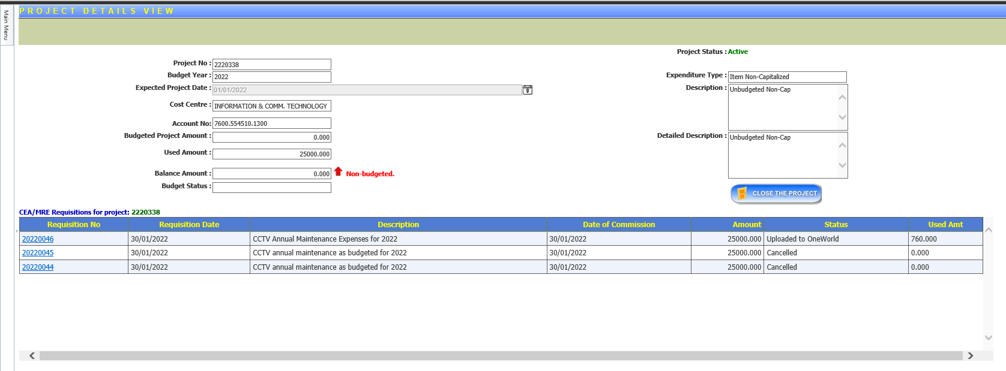

This process can also be automated by ICT by running a script to close all projects and CEA requests at once which usually requires a Helpdesk request ticket to be issued by the Finance department.

## Expenditure Request Management

This function would provide a set of features to manage the expenditure request. The completed expenditure request will be uploaded into JDE OneWorld system.

### Creating an Expenditure Request

The initiator will create an expenditure request by entering the relevant information based on the project details. The initiator would select an Item Type when creating an expenditure request, which can be any of the following types:

* Computer Related
* Human Resources
* Civil Engineering
* Mechanical Engineering
* Electrical Engineering
* Administration
* Transportation Related
* Furnitures and Stationaries
* Medical Related
* Safety Related
* Projects
* Office Equipment
* Quality Related
* Maintenance Related

The expenditure request is mapped to an approval group. Once all information is provided, the initiator will submit the request and would then initiate the approval process. Additionally, the system will facilitate the attachment of relevant external documents to the request. External documents can be attached only by the initiator or the department managers.

The system will check the available budget for the requested project. If the budget amount is not sufficient for the request, the system will notify the initiator who created the expenditure request and the department manager.

The following workflow approval process will take place upon submission of an expenditure request.

1. The request will be assigned to the Originator for approval. *(Notes: The Originator is the person who will check the accurateness of the information given in the request and is specified by the initiator during request submission.)*
2. Once the Originator approves the request, it will undergo cost center approval which involves the following roles:
   1. Superintendent – refers to the Head of the department
   2. Cost Center Manager – refers to the Manager of the department

*(Notes: In some departments, Superintendent and Cost Center Manager role refers to the same person. In such scenario, only one approval is required.)*

1. After the cost center approval is completed, the request will go to the Executive Manager – Operations if the Originator’s cost center is any of the following:
   1. 3250 – ROLLGRINDING
   2. 5200 – MECHANICALENGINEERING
   3. 5300 – ELECTRICALENGINEERING
   4. 5400 - CENTRAL ENGINEERING

Otherwise, the request will go to the Executive Manager – Finance for approval.

1. If the request is budgeted and the amount is greater than BD 20,000, or if the request is not budgeted and the amount is greater than BD 5,000, it will go to the following roles for approval in sequential order:
   1. General Manager
   2. Chief Executive Officer
2. If the request is budgeted and the amount is greater than BD 100,000, or if the request is not budgeted and the amount is greater than BD 50,000, the request will be assigned to the Chairman for final approval.

Once the approval process is completed, the request will be set into “Approved” status. All approved CEAs will be uploaded to JDE manually by the Executive Personal Assistant. This person has the authority to view all approved CEA requisitions in the system and can post it to JDE by clicking the “Upload to JDE” button.

At each approval level, the application checks the Leave Requisition module, which is a separate system, to validate the availability of an approver. If an approver is on-leave, the workflow will automatically assign the request to the substitute if it’s defined in the leave request. Otherwise, it will be assigned to the original approver.

Below summarizes the item category approvers as well as the workflow approval process:

**Item Category Approvers:**

|  |  |
| --- | --- |
| **Item Type** | **Approver Roles** |
| Administration | General Manager |
| Furniture & Stationary | General Manager |
| Maintenance Related | General Manager |
| Medical Related | General Manager |
| Office Equipment | General Manager |
| Projects | General Manager |
| Quality Related | General Manager |
| Civil Engineering | Executive Manager - Operations |
| Electrical Engineering | Executive Manager - Operations |
| Mechanical Engineering | Executive Manager - Operations |
| Computer Related | Senior Group ICT Manager |
| Human Resources | Executive Manager - Administration |
| Safety Related | Head of HSE |
| Transportation Related | Head of HSE |

**Workflow Approval Process:**

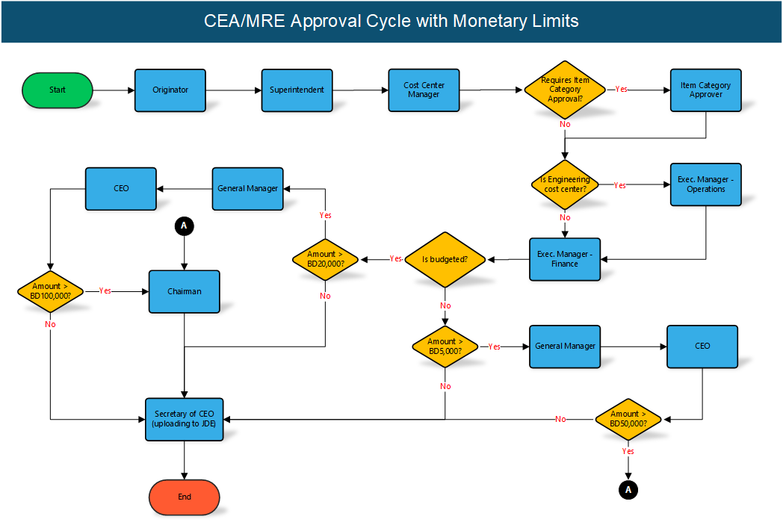

### Integration of Purchase Requisition

Once the CEA request is approved and posted in JDE, a Purchase Requisition request can be created through the GAP system to consume the CEA request. The external system will automatically fetch the relevant information from the CEA request and will display the data in the PR submission form.

### Tracking of Expenditure Request

The system provides a facility to track the expenditure request in various statuses such as creation, pending for approval, final approval, budget approved, budget not approved, etc.

### Maintenance of Completed CEA

The finance department will have functionality to close completed Projects and CEA requests for specific fiscal year. No CEA request can be created against a close or cancelled Project. Likewise, no Purchase Requisition request can be created against a closed or cancelled CEA/MRE request.

### Validations

The full report about the CEA/MRE request can only be printed if the approval process is completed.

### Non-functional

All entries, user actions will be logged for audit purposes.

## System Administration

### Approval Group Management

There are 2 main approval group types defined in the system which are as follow: 1) Approval Groups and 2) Non-Approval Groups. The Approval Groups consist of the required approvers defined for each department in sequential order. The Non-approval Groups comprise of system-defined approver groups that have different access permission. The following tables briefly summarizes the approval roles defined for each group type.

**Approval Groups:**

|  |  |  |  |
| --- | --- | --- | --- |
| Group Name | Sequence | Description | Condition |
| Superintendent | 1 | Refers to the department’s section head | Common for all department |
| Cost Center Manager | 2 | Refers to the manager of the department | Common for all department |
| Executive Manager - Finance | 3 | CFO of the company | Common for all department |
| General Manager | 4 | As the name implies, refers to the GM of the company. | * If project is budgeted and amount is greater than BD 20,000 * If project is not budgeted and amount is greater than BD 5,000 |
| CEO | 5 | Chief Executive Officer | * If project is budgeted and amount is greater than BD 20,000 * If project is not budgeted and amount is greater than BD 5,000 |

|  |  |  |  |
| --- | --- | --- | --- |
| Chairman | 6 | As the name implies, refers to the chairman of the company. | * If project is budgeted and amount is greater than BD 100,000 * If project is not budgeted and amount is greater than BD 50,000 |

*System Screenshot:*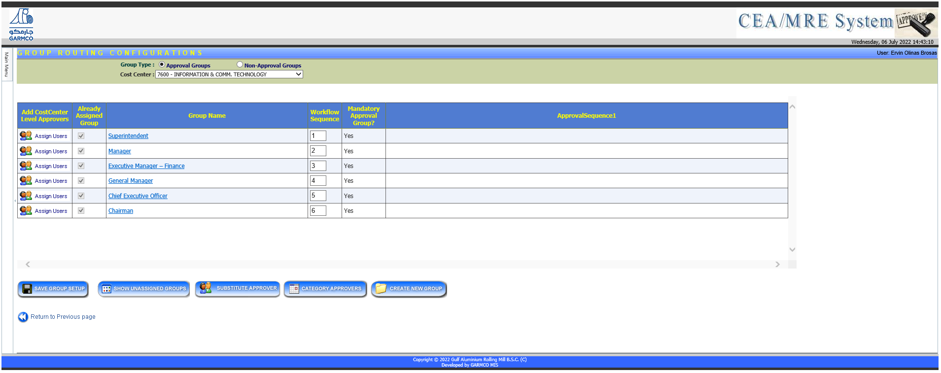

**Non- Approval Groups:**

|  |  |
| --- | --- |
| Group Name | Description |
| System Administrators | Members of this group have full access to all functions in the system |
| Secretary of CEO | Authorized persons who can upload the approved CEA request into JDE OneWorld |
| Department Secretary | Members can create CEA request and view submitted requisitions for all departments he/she has access. |
| Finance Users | Members can view, modify, close, and create new projects |
| Guest | Members have read-only access to all accessible forms in the system |

*System Screenshot:*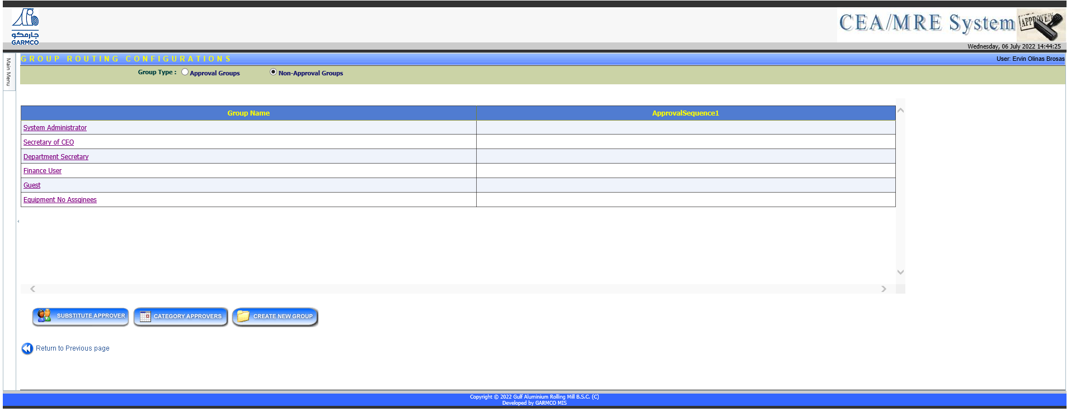

### Approver Substitute Setup

System Administrators can define the substitute of specific approver which will override any substitute definition in the Leave Requisition system.

*System Screenshot:*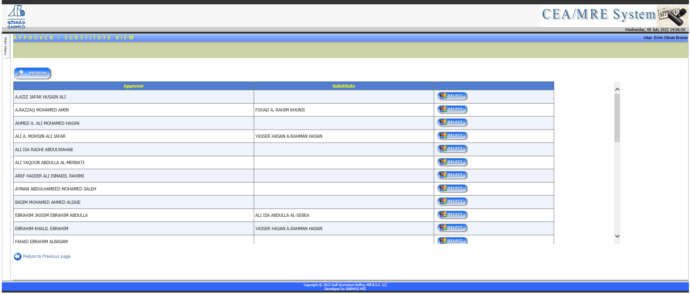

### Item Category Approver Setup

System Administrators can create a new item type as well as the assigned approver. For more information about the various item category approvers, please refer to the Creating an Expenditure Request section.

*System Screenshot:* 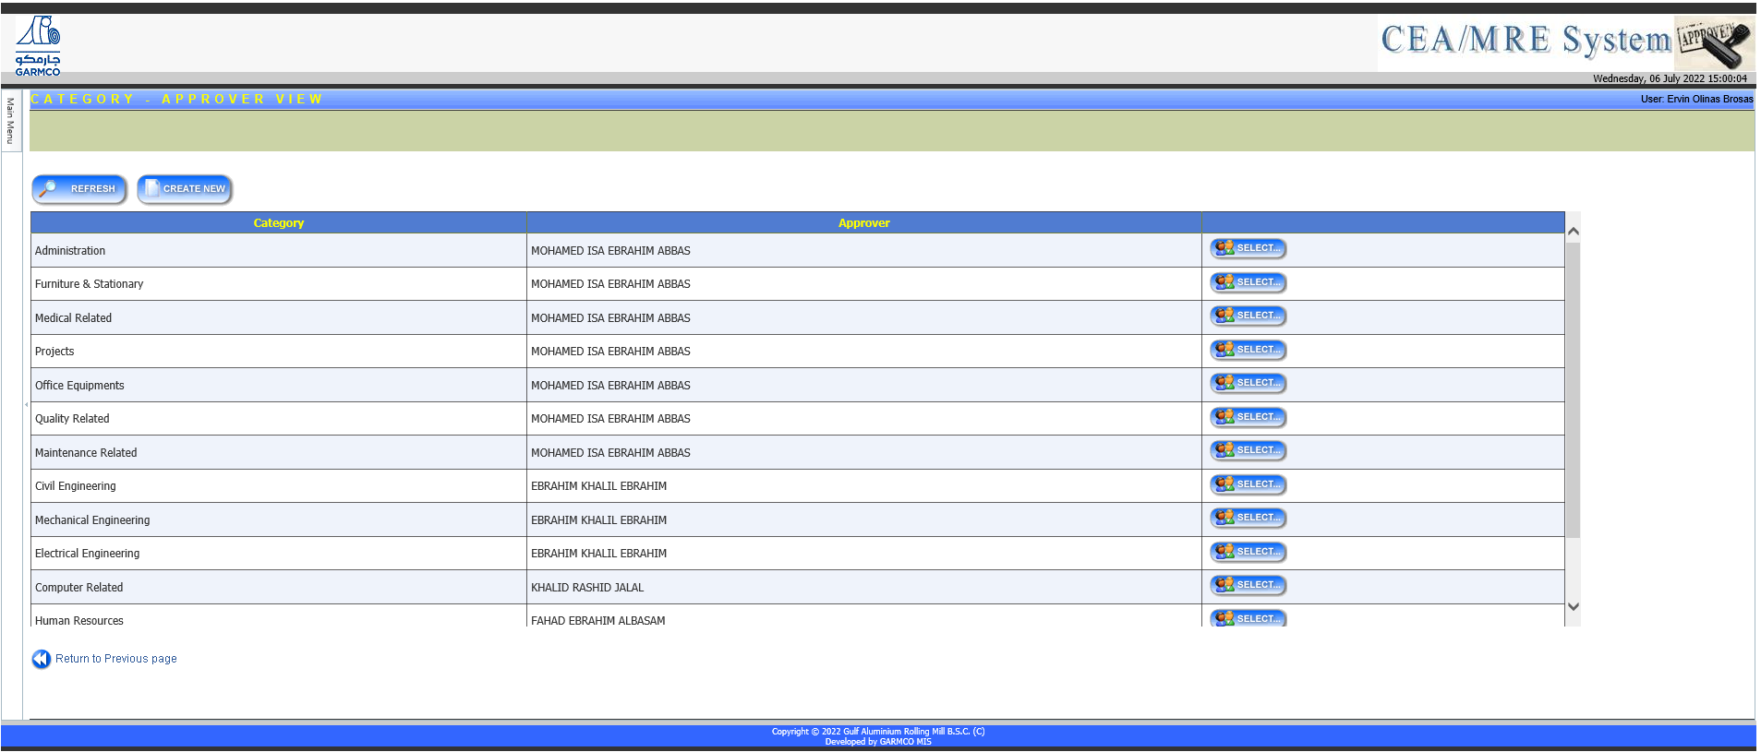

### Role Security Setup

There are 6 built-in role types defined in the system which are used to configure the access permission given to a group. Each role has predefined access level to specific functions or pages in the system. The definition of each role and its associated access are summarized in the table below.

|  |  |
| --- | --- |
| Role Name | Description |
| Account User | Has permission to do the following functions:   * Create and manage CEA request * View and modify project details * View approval status * View and print reports |
| Approver | Has permission to do the following functions:   * View CEA request details * View project details * View and print reports |
| Read Only | Has permission to do the following functions:   * View CEA request details * View project details |
| Requisition User | Has permission to do the following functions:   * Create and view CEA request * View project details * View approval status * View and print reports |
| System Administrator | Has full access to all functions in the system which include the following:   * Create, modify, close, and view project details * View and manage submitted CEA request * Load projects into the system from Excel sheet * Post approved CEA request to JDE system * View and manage reports * Group administration – assign approver substitute, define Item Category Approvers, create new group, assign role to a group, map user to Approval and Non-Approval Groups * Page security setup |
| Upload to OneWorld | Has permission to do the following functions:   * View CEA request * View project details * Post approved CEA request to JDE system |

*System Screenshot:* 